Name: Answer KEY___________ Date _______________ Class Period ______
Unit 2: Rate, Ratio, Proportional Reasoning - STUDY GUIDE

1) __See ratio table-many solutions______

2)______30_______

3)________6_______

4) ______220______

5)______49_______

6A)
Pink’s bracelets cost _$2.03__________

6B)
Carrie’s bracelets cost ____$2.50_____

6C) Who has the better deal? ____Pink______

- Write an equivalent ratio to 6:7 (in other words…it simplifies to 6:7).
6 | 12 | 18
7 | 14 | 21

- Twelve is 40% of what number?
$\frac{is}{of}$ =$\frac{\%}{100}$
$$\frac{12}{x}=\frac{40}{100}$$
12x100=1200
1200÷40=30
OR
$$\frac{12}{x}=\frac{2}{5}$$
2x6=12
5x6= 30
÷÷

- Find 15% of 40.
$\frac{is}{of}$ =$\frac{\%}{100}$
$$\frac{x}{40}=\frac{15}{100}$$

.15x40= 6
Or
15x4=600
600÷100=6
- Determine the missing value.

$$\frac{11}{20}=\frac{x}{400}$$
20x20=400
11x20=220
Or
11x400= 4400
4400$÷$ 20=220

- Usher earned $12.25 for 2 hours babysitting his agent’s children, which he gave to charity.
One week he babysat them for 8 hours. How much did he make for charity that week?

$\frac{12.25}{2}$= $\frac{x}{8}$
2x8= 16
12.25x2=49
Or
12.25x8=98
98÷2= 49

- Pink bought 15 bracelets for $30.45. Carrie Underwood bought 18 bracelets for $45.00.
Who got the better deal (LOWEST price per bracelet)? MUST SHOW ALL WORK!!!!! (Unit rate, divide by the denominator.
PINK CARRIE
$\frac{price}{item}=$ $\frac{30.45}{15}$ = $\frac{x}{1}$ $\frac{price}{item}$ = $\frac{45.00}{18}$ =$\frac{x}{1}$

30.45÷15=$2.03 45.00 ÷18= $2.50

- If 1 inch is approximately 2.54 centimeters, how many centimeters are

7) ___8.89cm______

8)_____120_______

9)__48 clowns__

10) ______________

equal in length to 3.5 inches?
$$\frac{2.54cm}{1 in}=\frac{x cm}{3.5in}$$

1x3.5= 3.5
2.54x3.5= 8.89cm

- The table below shows the cost for varying number of iTune albums.
If the relationship stays the same, determine the value of n.
Number of iTune albums | Cost
4 x6 | $24
5x6 | $30
12x6 | $72
20x6 | N=120
- The ratio of clowns to acrobats in a show is 12:4.
If there are a total of 64 clowns and acrobats in the show, how many
are clowns?
Hint: Make sure you are comparing the same things. What do you need to do to 12 and 4? add

12clowns+4acrobats=16 clowns and acrobats
$\frac{12clowns}{16clowns and acrobats}$=$\frac{x clowns}{64 clowns and acrobats}$
16x4=64
12x4=48

- The graph below compares cups to pints. Which of the following ordered
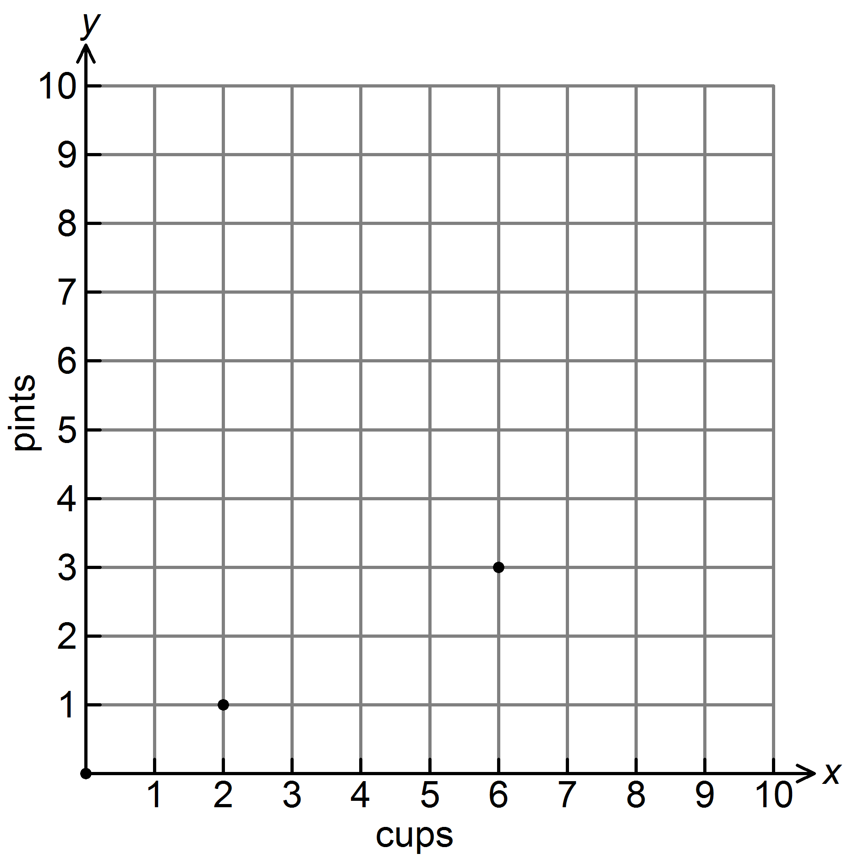
pairs would also satisfy this relationship?

A) (4, 1) B) (8, 4)

C) (8, 0) D) (1, 2)

11) ____$440____

12) 2 hours 30 mins

13)___55 miles____

14) ______________

- Brandy’s paycheck last week was $2,000. She would like to put 22% of her
pay check in her savings account. How much money should she put in her
savings account?

$$.22 x 2000=440$$
$$or$$
$$\frac{x}{2000}=\frac{22}{100}$$

100x20=2000
22x20= 440
- Jim drives his race car at a constant speed of 200 miles per hour.
Determine the number of hours it will take him to drive 500 miles.
$$\frac{200 miles}{1hour}=\frac{500 miles}{x hours}$$
500$÷$200= 2.5 hours

- Sally drove 660 miles in 12 hours. How many miles did she drive per hour?
$$\frac{660miles}{12hours}=\frac{x miles}{1hour}$$
12÷12=1
660÷12=55 miles

- Mr. Hague surveyed his students to determine their favorite summer sport.
The results are shown in the table below.
What percent of the students surveyed chose Football?

Sport | Boys | Girls
Football | 75 | 7
Soccer | 25 | 93
$$\frac{82girls and boys who chose football}{200totalstudents}=\frac{x\%}{100}$$

200÷2=100
82$÷$2= 41

Hint: How many total students are there? 200 41%
What are percent’s out of?100
15. In a class of 30 students, 20% returned their permission slips for the

15) __6 Students__

16)___40%_______

17A) How fast did Jerrod driver per hour?
__62 miles per hour___

17B) How fast did Martin drive per hour?
__61 miles per hour__

17) Who drove faster?
___Jerrod_____

school field trip. How many students returned their permission slips?

$$\frac{x}{30students}=\frac{20\%}{100}$$
$$\frac{x}{30students}=\frac{1}{5}$$
5x6=30
1x6=6

16. Pine Mountain Middle School held a car wash as a fundraiser.
Out of the 25 vehicles that were washed, 10 were cars.
What percent of the vehicles were cars?

$$\frac{10 cars}{25 vehicles}=\frac{x\%}{100}$$
25x4=100
10x4=40
0r
10÷25=.4
.4x100=40%
17. Jerrod drove 217 miles in 3.5 hours.
Martin drove 244 miles in 4 hours.
Who drove at the FASTEST rate of speed? MUST SHOW ALL WORK!
Jerrod
$$\frac{217miles}{3.5 hours}=\frac{xmiles}{1hour}$$
3.5÷3.5=1
217÷3.5= 62
Martin
$$\frac{244miles}{4 hours}=\frac{xmiles}{1hour}$$

4$÷4=1$
244÷4= 61

