Math 67 Name ___________________________________
Unit 7: Rational Explorations: Numbers and their Opposites Date _______________
Post Test

Knowledge and Understanding

- What does the absolute value of a number tell you about the number?

- Describe how to use a number line to order integers.

Proficiency of Skills

- Evaluate:
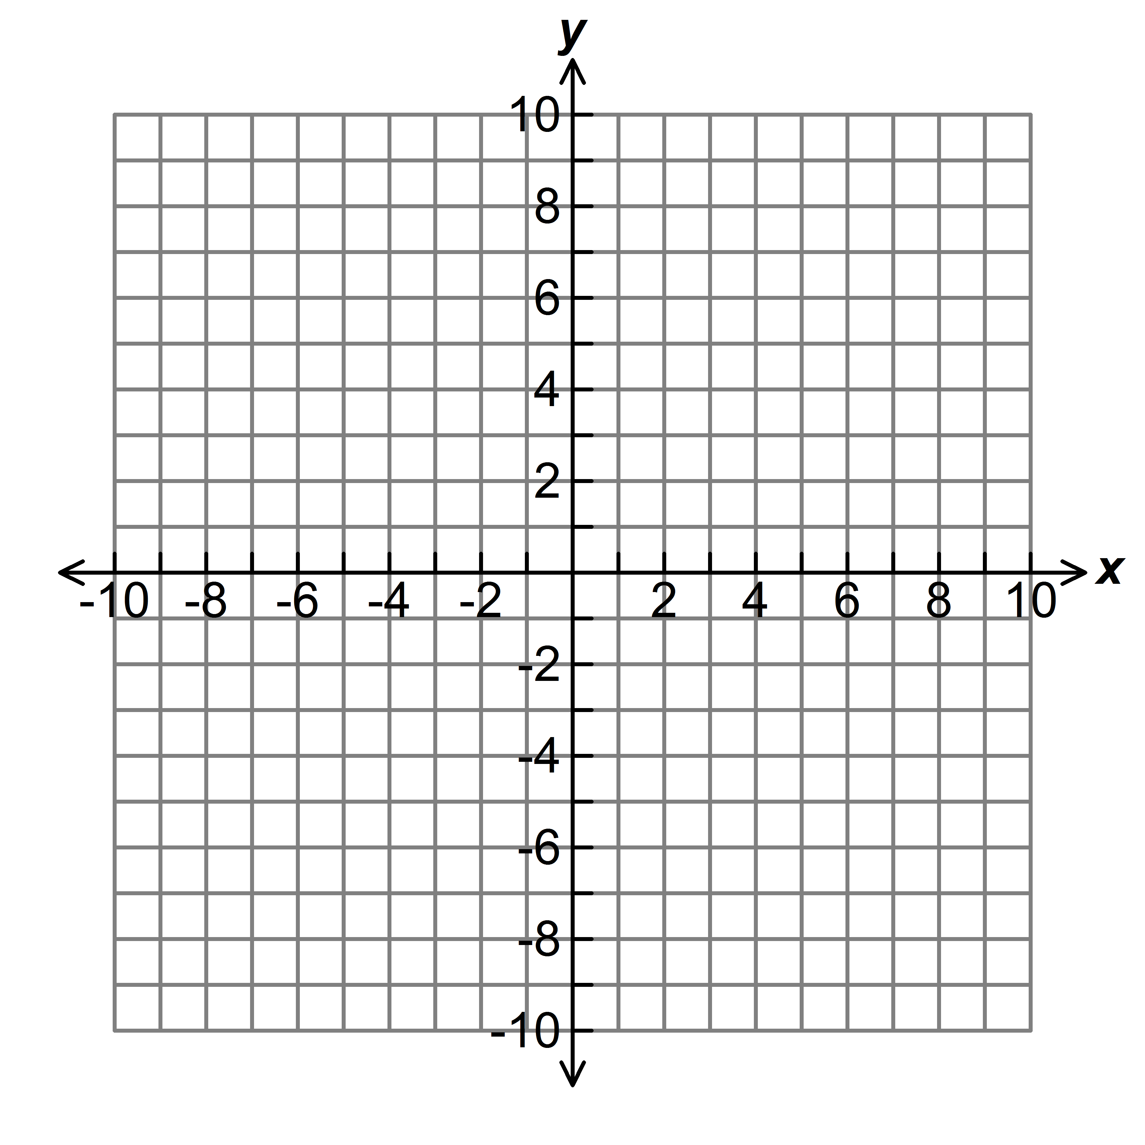
- Evaluate:

- Order from least to greatest: 6, -2, 0, -3, -10

- Plot and label the following points on the coordinate plane:
A (-3, 4); B (0, -2); C (4, -5); D (-3, -5)

- Plot 4 and its opposite on the number line below. Label both numbers.

0
1
-1

Application

- Ciana is on a mountain top that is 18,240 feet above sea level. She descends 1,260 feet. How many more feet must she walk down the mountain to reach sea level?

- The table below shows the average daily temperature in December for 5 cities in Alaska.
City | Temperature (⁰C)
McKinley Park | -18
Bethel | -16
Fairbanks | -25
McGrath | -24
King Salmon | -12

- Write an inequality statement comparing the temperature of Fairbanks and King Salmon.

- Order the cities from coldest to warmest.

- Graph point A (-3, 5) on the coordinate plane below.

- Reflect the point across the x-axis.
- What is the distance between point A and the reflected point? Justify your answer.

- James owes $3 in late fees to the library. Represent this value on the number line below.

0
1
-1
- Amanda owes $5 in late fees to the library. Represent this value on the number line.
- How much more does Amanda owe than James? _________ Explain how you could use the number line to determine this answer.

Use the map below for questions 12 – 14.
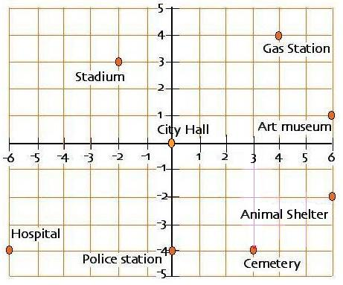

- Name the ordered pair that represents the location of the police station.

- How many blocks apart are the animal shelter and the art museum? Justify your answer with an equation.

- Name the building that is located in quadrant 3.

- Graph (-6, 4) and (-6, -2) on the coordinate plane below.
- Reflect both points across the y-axis to form the vertices of a rectangle. Name the two reflected ordered pairs.

- What is the perimeter of the rectangle?

- What is the area of the rectangle?

- If you reflected the ordered pair (-2, 5) across the y-axis, what would be the coordinates of the reflection?
A. | (-2, -5) | B. | (2, 5) | C. | (2, -5) | D. | (-2, 5)

- Which statement below is NOT true?
A. | -3 < -1
B. | -2 ≥ -5
C. | -4 ≤ -4
D. | 3 < -4

- It is 65 degrees above zero in Miami. It is 27 degrees below zero in Anchorage. Use the number line below to determine how many degrees warmer it is in Miami than in Anchorage.

0⁰ F
-27⁰ F
65⁰ F

A. | 82⁰F | B. | 92⁰F | C. | 38⁰F | D. | 65⁰F

- A flea is jumping around on the number line. He starts at 3 and jumps 5 units to the left. Where is he now on the number line?
0
1

A. | 3 | B. | 5 | C. | -5 | D. | -2
Performance Task

- A newly developed neighborhood has dedicated a portion of their land to be used as a children’s playground. The neighborhood would like to build a fence around a rectangular area of 96 square yards for a dog run. The coordinate planes below each represent the dedicated land. Each square on the grid represents one square yard. Each yard of fencing costs $18. Develop two plans for the neighborhood to choose from.
List the coordinates of the vertices and determine the price of the fencing for each plan. Then write a letter to the neighborhood explaining which design you recommend and why.

Plan 1  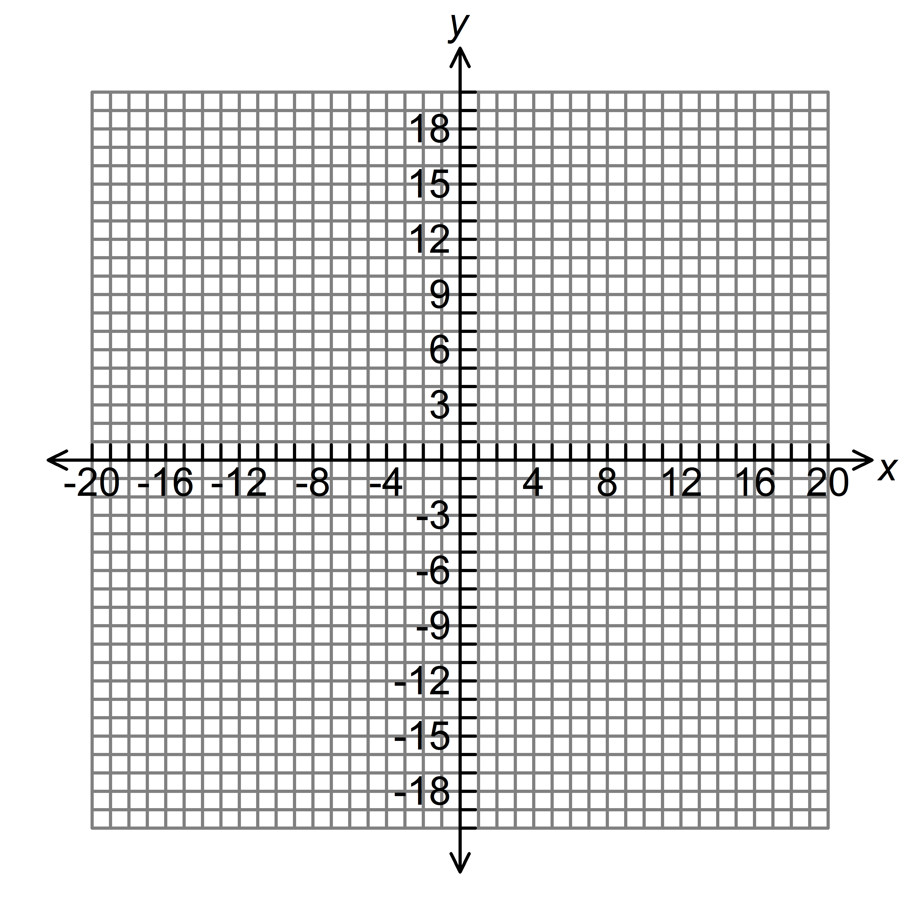 | Plan 2

Math 67
Unit 7: Rational Explorations: Numbers and their Opposites
Post Test Answer Key
Problem | Standard | Answer
1. | MCC6NS.7c | The absolute value of a number tells you the distance from zero on the number line.
2. | MCC6NS.7a | When numbers are graphed on a number line, the numbers can be read from left to right to order them from least to greatest.
3. | MCC6NS.7c | 5
4. | MCC6NS.7c | -3
5. | MCC6NS.7b | -10, -3, -2, 0, 6
6. | MCC6NS.6c | 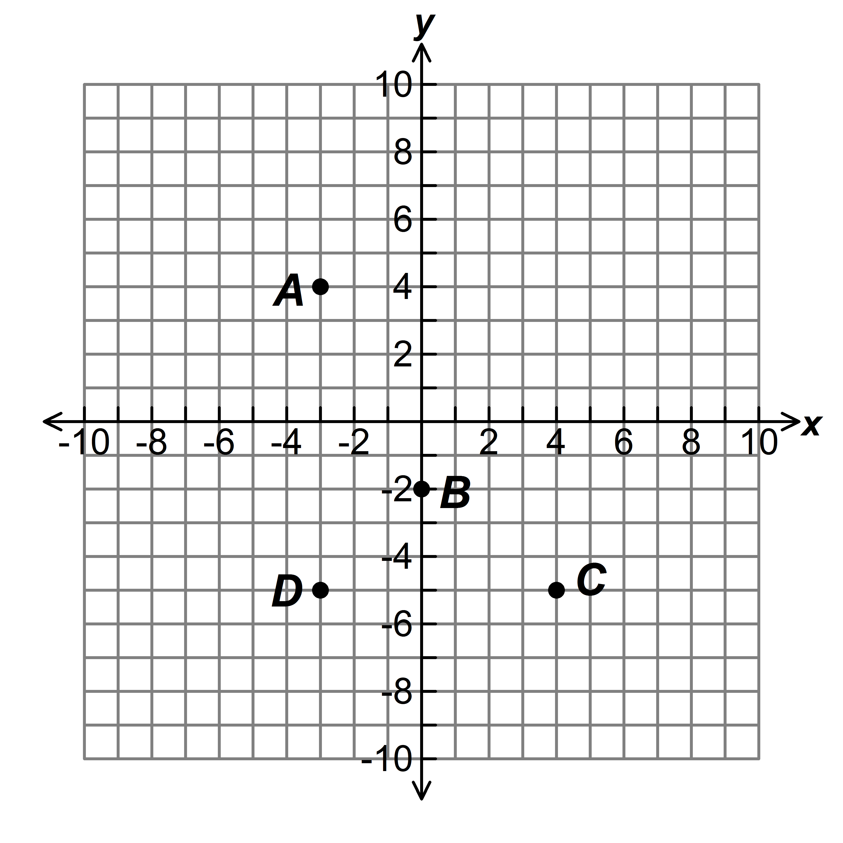
7. | MCC6NS.6a | 0  1  4  -4
8. | MCC6NS.5 | 16,980 feet
9. | MCC6NS.7b | a. -25<-12 or -12>-25  b. Fairbanks, McGrath, McKinley Park, Bethel, King Salmon
10. | MCC6NS.6b | 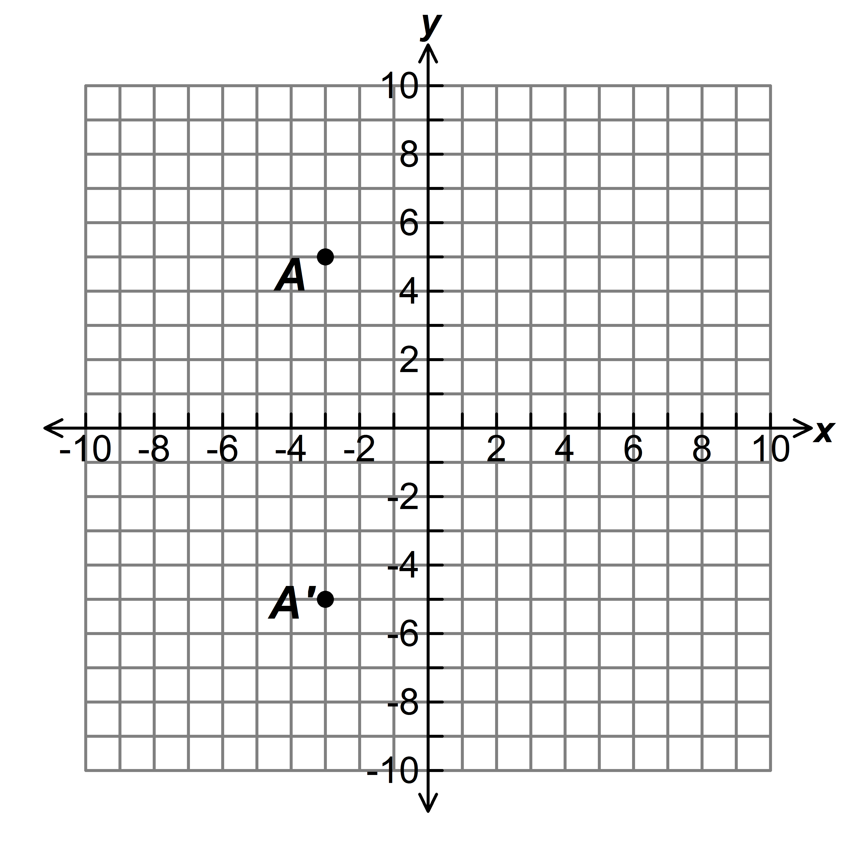  The two points are 10 units apart.
11. | MCC6NS.7c | 0  1  -5  Amanda  -3  James  Amanda owes $2 more than James because her point on the graph is 2 units farther to the left from zero than James’ point.
12. | MCC6NS.6c | (0, -4)
13. | MCC6NS.8 | ; The animal shelter and art museum are 3 blocks apart.
14. | MCC6NS.6 | Hospital
15. | MCC6G.3 | 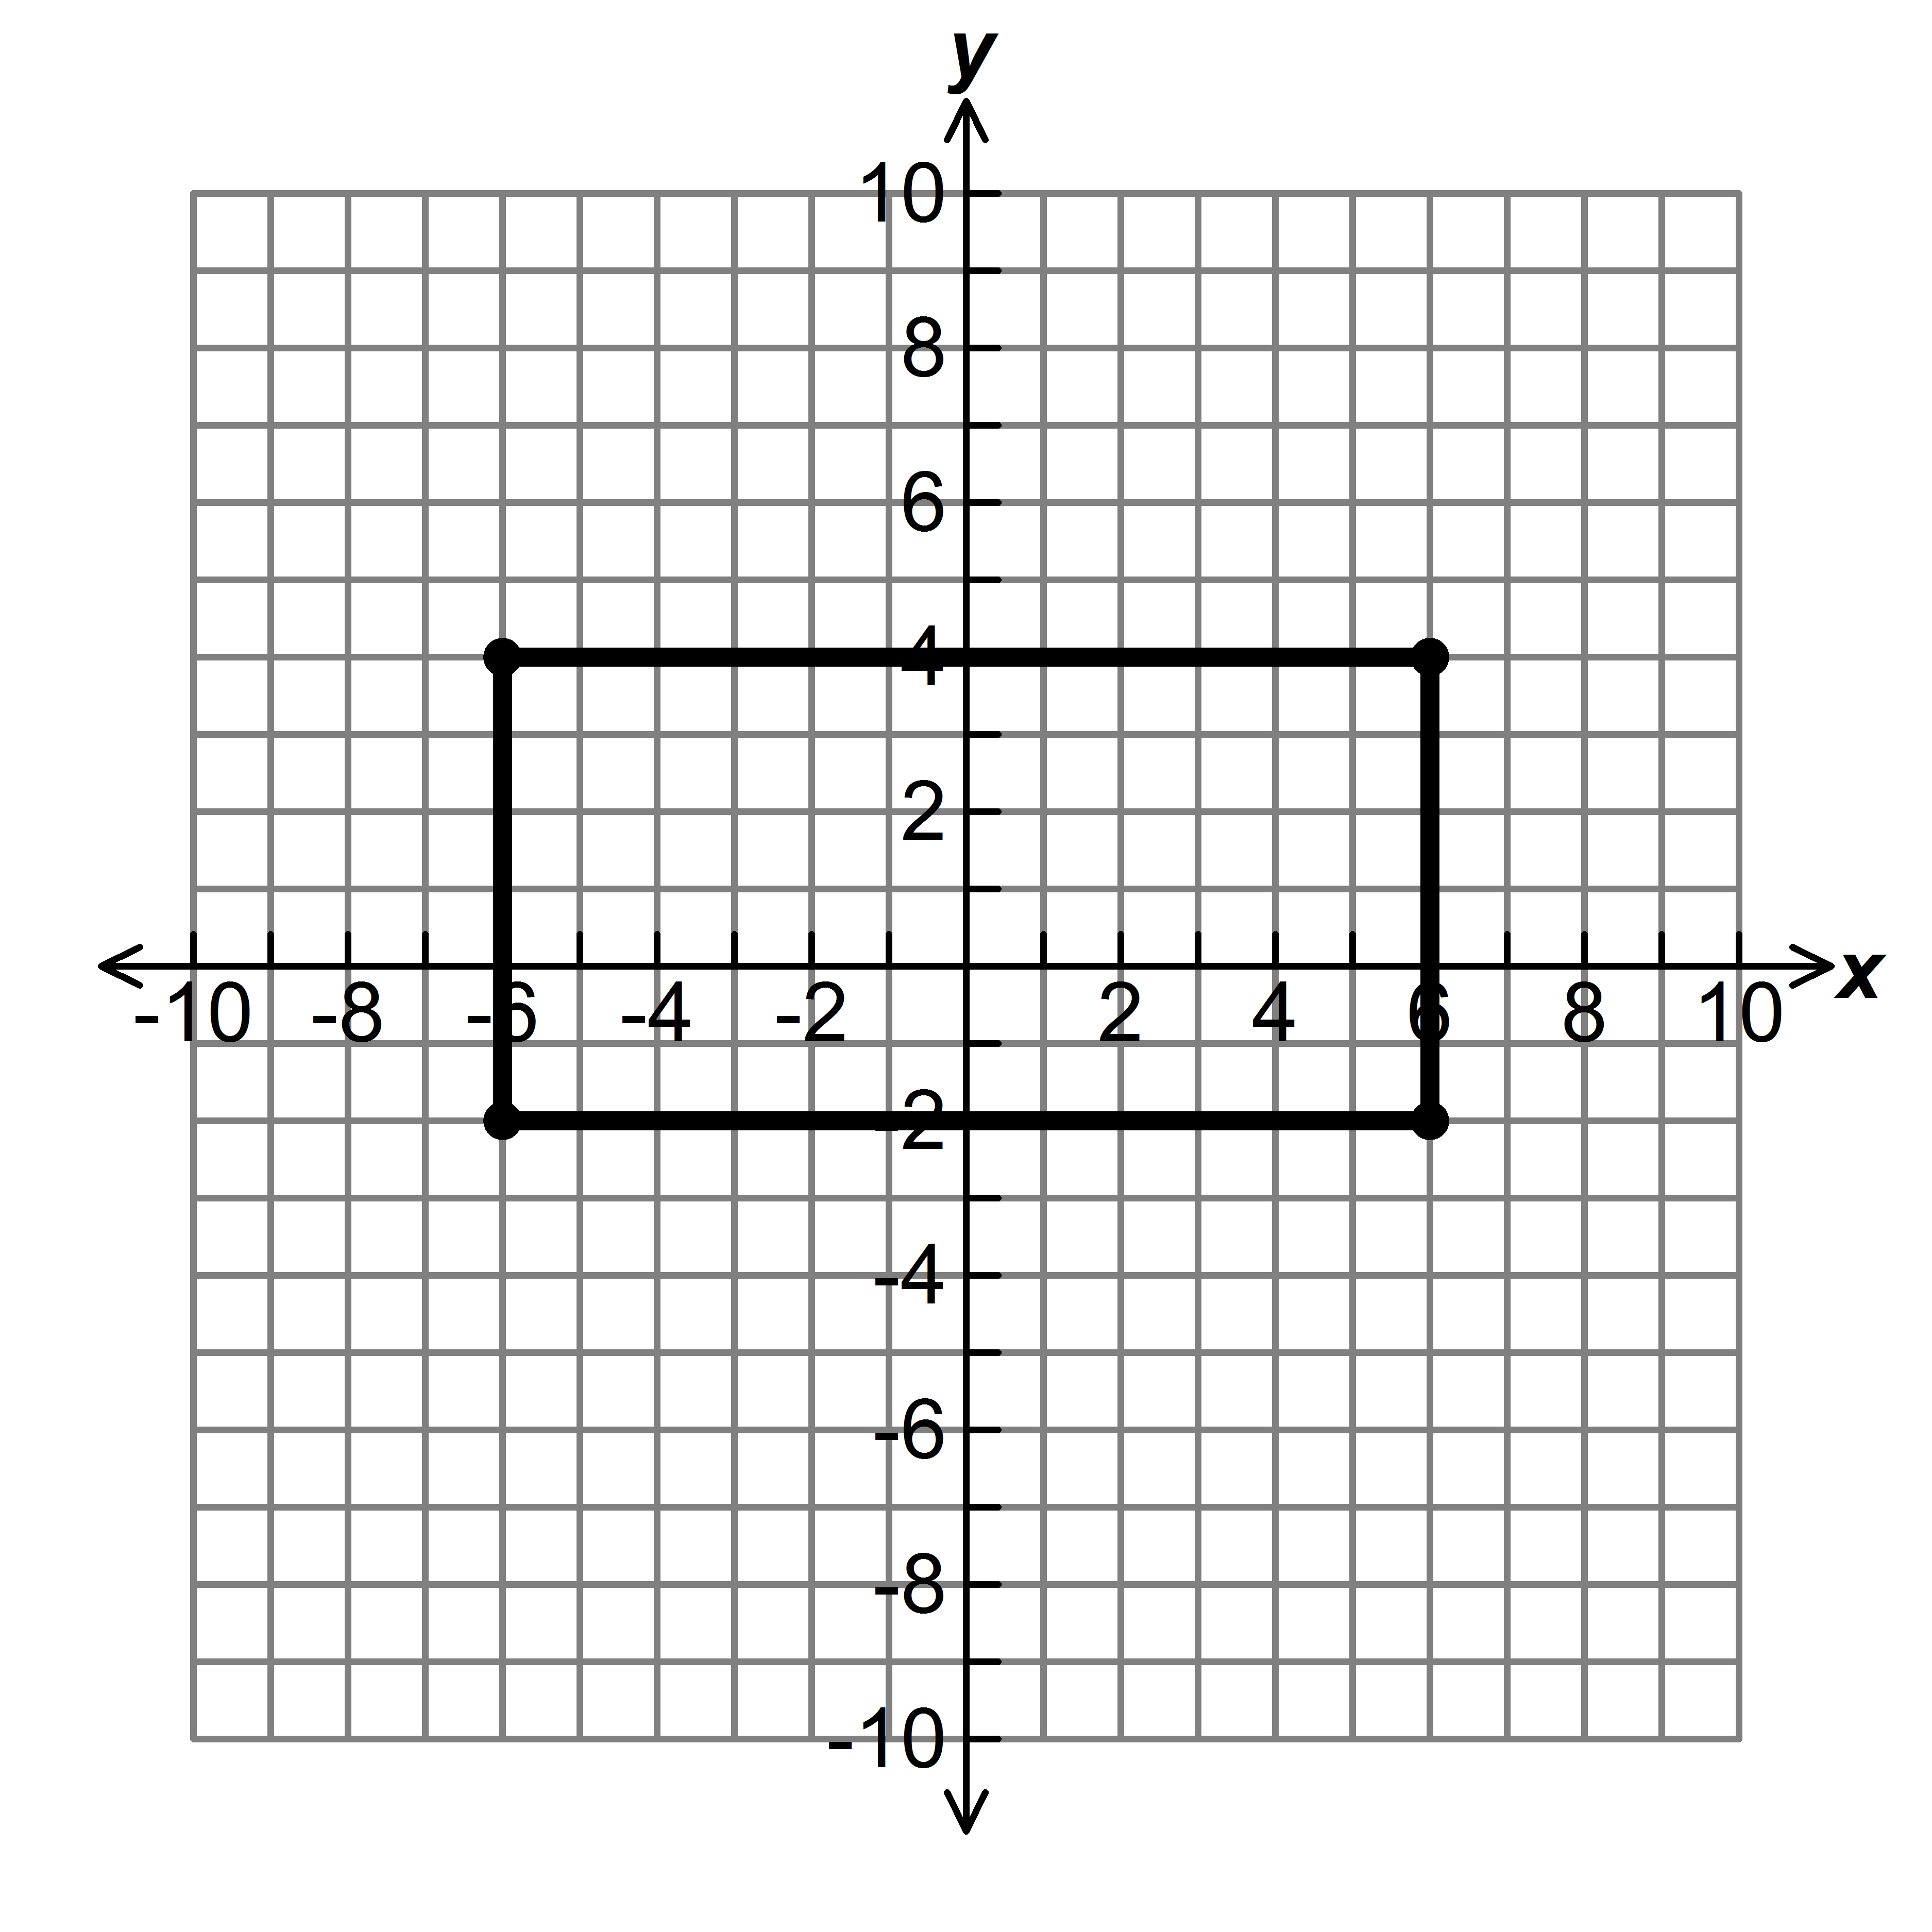  a. (6, 4) and (6, -2)  b. The perimeter is 36 units.  c. The area is 72 square units.
16. | MCC6NS.6b | B
17. | MCC6NS.7 | D
18. | MCC6NS.6 | B
19. | MCC6NS.6 | D
20. | MCC6G.3 | Answers will vary.

