Data Displays: Dot Plot, Histograms, and Box-and-Whisker Plots
Dot Plots
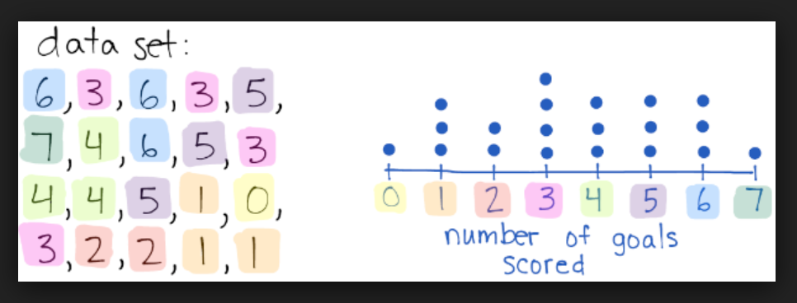
- A graphical display using dots
- Take data set, and display each piece of data using a dot above a number line.
Data Set:
Number of books read this school year

Histograms
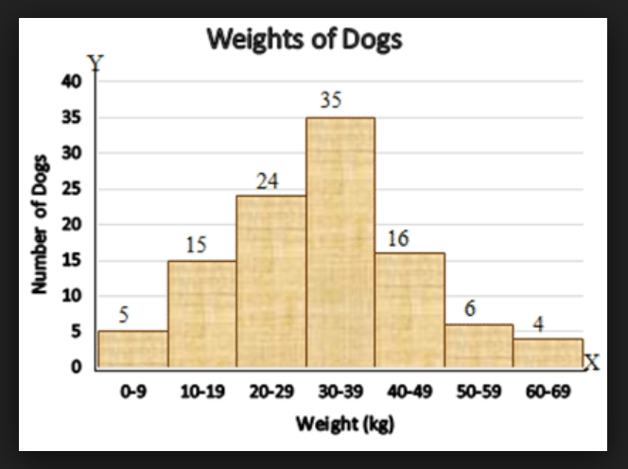
- Shows the frequency of data with bars.
- The bars touch (unlike a regular bar graph) due to the continuous nature of the data.
- Consists of two axes (sides) in order to show the frequencies and characteristics.
- Consists of intervals (ranges) that have the same amount of values in each.

Data Set:
Number of people living in your home

Intervals | Frequency (tally total for each interval)

Box Plot (A.K.A. Box and Whisker Plot)
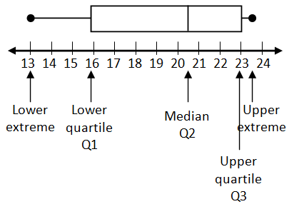
- Displays data along a number line and splits the data into quartiles (quarters, 4 sections)
- Each quartile represents 25% of the data (sizes may differ depending on the variability of the data.
- There are 5 pieces needed to graph a box plot: the minimum value (smallest), the maximum value (largest), the median (Q2), Lower Quartile (Q1), and the Upper Quartile (Q3).
HOW TO CREATE A BOX PLOT:
- Arrange data from least to greatest.
- Identify the minimum, maximum, and median
- Use the median to identify the upper half of the data, and the lower half of the data.
- Find the median of the upper half of the data, this will be your Upper Quartile (Q3).
- Find the median of the lower half of the data, this will be your Lower Quartile (Q1).
- Create, and plot the 5 values, on a number to display that graph.
Data Set:
Number of states visited by students

