Unit 2: Ratios and Proportional Reasoning Name _____________________________
Study Guide

- Write an equivalent ratio to 2:3. _____________
- The ratio of boys to girls in a class is 3:4. If there are 42 students in the class, how many are boys? ______
- Write the rate as a unit rate: $48 for 4 tickets. _______
- Joe drove 215 miles in 3 hours. Moe drove 240 miles in 4 hours. Who drove at the fastest rate of speed? _______ How fast was each person driving? Joe_______________ Moe ________________

Replace the x, y, and z in the tables of equivalent ratios with the correct number. Do not simplify the answers.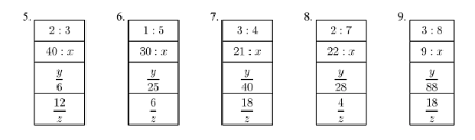
- The prices of 4 different bottles of shampoo are given in the table. Which bottle size is the best value? ________
Size | Price
24 ounces | $4.50
15 ounces | $2.30
8 ounces | $1.60
4 ounces | $0.95

- Determine the missing value. $\frac{16}{20}= \frac{x}{180}$

- The table below shows the number of each item sold at the concession stand. What might the ratio 3:2 represent?
Item | Quantity Sold
Popcorn | 20
Nachos | 15
Hot Dog | 25
Candy Bar | 30
- Using the same table above, what is the ratio of hot dogs to popcorn? _________
- What is the ratio of Nachos to all food items? __________
Use the double number line below to answer questions 15-18.

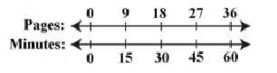
- How long will it take to read 27 pages? _________
- How many pages can be read in 15 minutes? _________
- How long will it take to read 90 pages? _________
- How many pages can be read in 2 hours? _________

Number of Books | Cost
3 | $24
5 | $40
12 | $96
20 | n
- The table below shows the cost for varying number of books. If the relationship stays the same, determine the value of n. ________

- The graph below compares cups to pints. Which of the following ordered pairs would also satisfy this relationship?
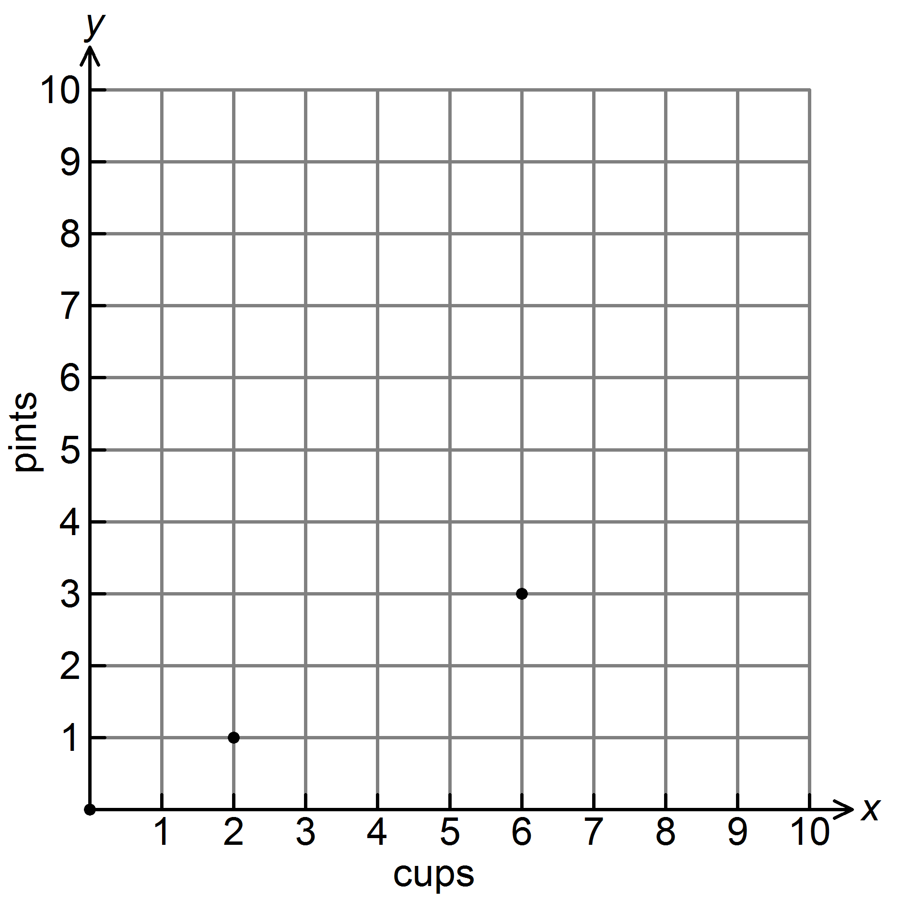
A. | (4, 2) | B. | (2, 4) | C. | (2, 0) | D. | (1, 2)

- Thirteen is 25% of what number? _____________
- Find 15% of 32. ______________
- If in a class of 40 students, 45% are in Band, how many students are in Band? ________
- Ann deposits 20% of her earning each week into her savings account. If she deposited $17 this week, how much did she earn? __________

- If 1 inch is approximately 2.54 centimeters, about how many centimeters are equal in length to 1 foot? _______

