Math 6 Name ___________________________________
Unit 6: Statistics Date _______________
Post Test
Knowledge and Understanding
- Define what constitutes a statistical question.

- What does it mean that data distribution can be described by the center, spread and overall shape of the data?

- What is the difference between measures of center and measures of variability?

Proficiency of Skills
- Find the measures of center of the following data: 8, 4, 3, 7, 6, 8.

- What is the median of the stem & leaf plot below?! Not required!
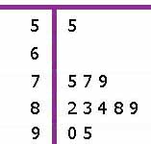

- Use the following data to create a box & whisker plot:
Age of students that downloaded “The Hunger Games” at Fiction Secondary School
12 12 15 16 17 16
15 13 11 18 15 14
15 16 16 15 13 13

Identify:
Minimum:____
Maximum:____
Median:____
Lower Quartile:____
Upper Quartile:_____
Interquartile Range:_____

- Use the following data to create a histogram:
Number of Text Messages per Minute
6 8 4 1 10 3
5 2 0 2 3 3
12 5 2 1 3 2

What does the shape & spread of the histogram tell you about the data?

- Create a dot/line plot of the following data:
Pull ups completed by students during a fitness test
3 3 10 1 0 2
3 7 0 12 2 5
0 2 8 10 11 2

- Find the mean absolute deviation for the following quiz scores: 92, 85, 80, 95, 88.

What does it indicate for this data?____________________________________________________________

Application

- The line plot below shows the number of pets in each household. Which measure of center, the mean or the median, better shows the typical number of pets in each household? Explain why.

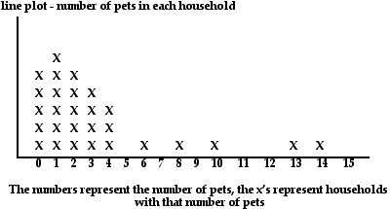

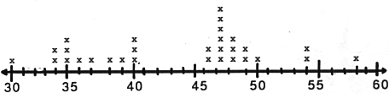
- The line plot below shows the ages of people that use hands-free devices in their vehicles. Which measure, the range or the interquartile range, best describes the variability in the ages of people using hands-free devices in their vehicles?

- Ten students were surveyed to find out how much weekly allowance they received. The following data was collected: $5, $5, $7.50, $10, $10, $10, $15, $15, $20, $50. Which measure of center would be most appropriate to describe the typical allowance for this group of students? Justify your reasoning.

- Identify the interquartile range from the box plot below.

A. | 35 | B. | 25 | C. | 20 | D. | 5
- The line plot below shows the number of miles swam by each member of the swim team.

 | X  X | X  X  X | X  X  X  X | X
0 |  |  |  | 1
Miles
What is the total distance the swim team swam?
A. | 6 miles | B. | 5 miles | C. | miles | D. | miles

- Amanda’s test scores are 85, 93, 84, and 88. What does she need to score on the next test for her test average to be a 90?

A. | 93
B. | 95
C. | 97
D. | 100

- Zeke has a jar of different types of buttons. Which of the following is a statistical question someone could ask Zeke about his button collection?

A. | How many buttons are in the jar?
B. | How large is the largest button in the jar?
C. | What materials were used to make these buttons?
D. | How many buttons are green?

- The ARC Trucking Company keeps records of the weekly distances driven by each of its drivers. The distances driven by Conrad during the last 4 weeks are shown in the table.

Week 1 | 2,895
Week 2 | 2,895
Week 3 | 2,964
Week 4 | 2,762

Which measure of the data would NOT be a good predictor of the number of miles that Conrad might drive next week?
A. | mean | B. | median | C. | mode | D. | range

- The following table shows the number of pages in novels that Kelly read for pleasure each month during the school year.
Month | Sept. | Oct. | Nov. | Dec. | Jan. | Feb. | Mar. | Apr.
Number of Pages | 370 | 393 | 380 | 376 | 396 | 372 | 385 | 391

If Kelly only read 125 pages during the month of May, which measure of data changed the most?

A. | mean
B. | median
C. | mode
D. | All measures were affected equally.
- The hourly wages for seven workers are: $5, $12, $13, $10, $6, $5, $12. Determine the mean absolute deviation of the data to the nearest cent.

A. | $3.00 | C. | $3.21
B. | $3.14 | D. | $3.42

Performance Task
- Below are two sets of data containing the number of books read over the summer by Palmer Middle Schools’ Book Club and Durham Middle Schools’ Book Club.

Books Read by Members of Palmer Middle School’s Book Club |  |  |  |  |  | Books Read by Members of Durham Middle School’s Book Club
6 | 5 | 5 | 6 | 6 |  | 6 | 13 | 6 | 1 | 3
7 | 7 | 5 | 7 | 6 |  | 6 | 0 | 10 | 12 | 3
A.) Find the mean, median and mode for each set of data & describe what they tell you about the data.
B.) Find the Mean Average Deviation for both sets of data & describe what it tells you about the data.
Math 6
Unit 6: Statistics
Post Test Answer Key
Problem | Standard | Answer
1. | MCC6.SP.1 | A statistical question is one typically where answers will vary.
2. | MCC6.SP.2 | Data distribution can be described by the center (mean, median, mode), spread (range); and overall shape (skewed left, normal, skewed right).
3. | MCC.6.SP.3 | A measure of central tendency is important because it allows us to quickly answer the most basic question we usually have about our data; Measures of variability tell us how spread out the scores in a distribution are.
4. | MCC6.SP.5.c | Mean=6  Median=6.5  Mode=8
5. | MCC6.SP.5.c | Median=83—not required
6. | MCC6.SP.4 | 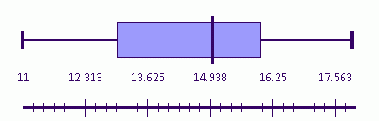  Minimum: 11  Maximum: 18  Median: 15  Lower Quartile: 13  Upper Quartile: 16  Interquartile Range: 3
7. | MCC6.SP.4 | Results will vary.  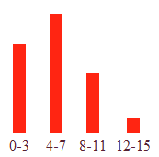  The shape is skewed left and the spread is 12.
8. | MCC6.SP.4 | x  x x x  x x x x  x x x x x x x x x x  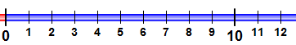
9. | MCC6.SP.5.c | MAD=4.4 This indicates that the average difference of the quiz scores from the mean is 4.4 points.
10. | MCC6.SP.5.d | The shape is skewed left with data mostly from 0-4; the mean is affected by outliers; the median is not affected by outliers-so the median would describe the data better.
11. | MCC6.SP.5.d | The shape is fairly normal and most of the data is between 34 and 50; the range shows the spread with quite a bit of variation; the interquartile range shows the spread of the middle half includes 37 to 48; since 80% of the ages are 48 or less, the interquartile range would be a better measure.
12. | MCC6.SP.5 | The median would be the best measure of center because the data value of $50 would skew the mean.
13. | MCC6.SP.5 | B
14. | MCC6.SP.4 | A
15. | MCC6.SP.5 | D
16. | MCC6.SP.1 | C
17. | MCC6.SP.5 | D
18. | MCC6.SP.2 | A
19. | MCC6.SP.5 | B
20. | MCC6.SP.5 | Palmer Durham  Mean 6 6  Median 6 6  Mode 6 6  A.  The measures of center show that the typical student at each school read 6 books over the summer.  B. MAD at Palmer is 0.6. MAD at Durham is 3.4. The MAD tells that the data is more clustered about the mean for Palmer than for Durham.

